**DOKUMENTASI API**

**Endpoint :** https://backend-dot-capstone-project201123.et.r.appspot.com

1. **Register**

* Method: POST
* URL: /register
* Request body:

{

"name":"", //VARCHAR(250)

"password":"", //VARCHAR(50)

"email":"", //VARCHAR(100)

"posisi":"" //VARCHAR(50)

}

* Response:

200 OK

1. **Login**

* Method: GET
* URL: /login
* Request body:

{

"name":"", //VARCHAR(250)

"password":"" //VARCHAR(50)

},

* Response:

200 OK

1. Mendapatkan seluruh barang

* Method: GET
* URL: /barang
* Request body: -
* Response:

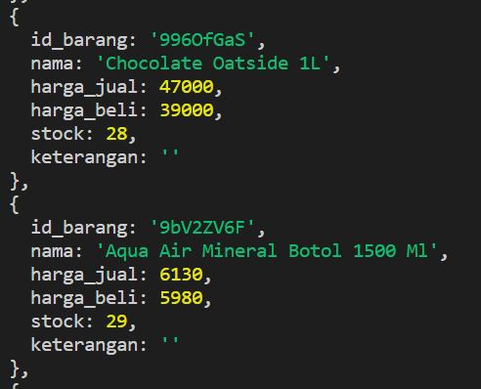

1. **Mendapatkan barang berdasarkan id**

* Method: GET
* URL: /barang/:id
* Parameter: id
* Request body: -
* Response:

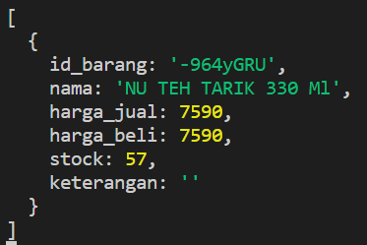

1. **Menambahkan barang**

* Method: POST
* URL: /barang
* Request body:

{

"id":"", //VARCHAR(8)

"nama":"", //VARCHAR(100)

"hargaJual":"", //INT

"hargaBeli":"", //INT

"stock": , //INT

"keterangan": //TEXT (boleh kosong)

}

* Response:

200 OK

1. **Mengupdate barang**

* Method: PUT
* URL: /barang/:id
* Parameter: id
* Request body:

{

"nama":"", //VARCHAR(100)

"hargaJual":"", //INT

"hargaBeli":"", //INT

"stock": , //INT

"keterangan": //TEXT (boleh kosong)

}

* Response: 200 OK

{

"fieldCount": 0,

"affectedRows": 1,

"insertId": 0,

"info": "Rows matched: 1 Changed: 1 Warnings: 0",

"serverStatus": 2,

"warningStatus": 0,

"changedRows": 1

}

1. **Menghapus barang**

* Method: DELETE
* URL: /barang/:id
* Parameter: id
* Request body: -
* Response: 200 OK

1. **Mendapatkan beli berdasarkan id**

* Method: GET
* URL: /barang/:id
* Parameter: id
* Request body: -
* Response: 200 OK

1. **Restock barang**

* Method: PUT
* URL: /restock
* Request body:

{

"id_barang": "ai-Wb_1c" , //VARCHAR(8)

"jumlah": 100 //INT

}

* Response: 200 OK

1. **Restock seluruh barang**

* Method: PUT
* URL: /restockArray
* Request body:

[

{

"id_barang": "ai-Wb_1c" , //VARCHAR(8)

"jumlah": 100 //INT

},

{

"id_barang": "-964yGRU" , //VARCHAR(8)

"jumlah": 90 //INT

}

]

* Response: 200 OK

1. **Menambahkan beli**

* Method: POST
* URL: /beliJson
* Request body:

{

"id": "YRDBMyfJ",

"total": 121600,

"tanggal": "2023-01-03 17:00:00",

"data": [

{

"id_barang": "ai-Wb_1c",

"nama": "Kokoro Pulpen Zebra Sweet Gel 0.5Mm (1Pak/12Pcs )",

"harga": 57500,

"jumlah": 2

},

{

"id_barang": "yuT5eyGd",

"nama": "Fruit Tea Minuman Teh 500 Ml",

"harga": 6600,

"jumlah": 1

}

]

}

* Response: 200 OK

1. **Mendapatkan beli**

* Method: GET
* URL: /beli
* Request body:

{

"idBeli": "AJVW_y2T", //VARCHAR(8)

}

* Response: 200 OK

1. **Mendapatkan seluruh beli**

* Method: GET
* URL: /beli_all
* Request body: -
* Response: 200 OK

{

"id_transaksi": "AJVW_y2T",

"id_barang": "bAQwvb2N",

"id_beli": "06OyXgem",

"jumlah": 10,

"total": 77296,

"tgl_pembelian": "2023-03-28 11:34:50",

"total_harga": 404874

},

{

"id_transaksi": "EKKG7FXa",

"id_barang": "1-njaQF1",

"id_beli": "06OyXgem",

"jumlah": 2,

"total": 22890,

"tgl_pembelian": "2023-03-28 11:34:50",

"total_harga": 404874

},

{

"id_transaksi": "Mz7ze29u",

"id_barang": "bcYYZQrk",

"id_beli": "06OyXgem",

"jumlah": 5,

"total": 7400,

"tgl_pembelian": "2023-03-28 11:34:50",

"total_harga": 404874

},